Open Ended Lab 1

Student-Name: Rabeea Anjum | Roll-no : 23-CSE-09
Lab Instructor Signature _____________ | Date_________________________________

Min-max Algorithm for Decision Making in Connect Four

Objective:
To implement the Min-max algorithm for decision-making in Connect Four, simulating a perfect player for an optimal game strategy.

Game Chosen: Connect Four
Connect Four is a two-player board game where the objective is to be the first to get four of one's pieces in a row (vertically, horizontally, or diagonally). The game is played on a 7x6 grid. Each player takes turns dropping their colored disc into one of the seven columns. The disc will fall down to the lowest available spot in that column.

Min-max Algorithm Overview
The Min-max algorithm is a decision rule for minimizing the possible loss for a worst-case scenario. When dealing with gains, it is referred to as "max-min" — to maximize the minimum gain. The algorithm simulates all possible moves in the game, evaluates each one based on a utility function (win = +1, draw = 0, loss = -1), and selects the optimal move.
The Min-max algorithm:
- Generates all possible moves in the current game state.
- Evaluates the result of each move by recursively calling Min-max for each possible move until a terminal state (win, loss, or draw) is reached.
- Maximizes or minimizes the score for the maximizing and minimizing players (computer vs human).
- Selects the optimal move for the maximizing player, assuming both players play optimally.

Connect Four Implementation with Min-max Algorithm

Code Implementation:
import math

# Define the Connect Four board
ROWS = 6
COLS = 7
board = [[" " for _ in range(COLS)] for _ in range(ROWS)] # Empty board

# Helper function to print the board
def print_board(board):
for row in board:
print("|".join(row))
print("-" * 13)

# Check if a move results in a win
def check_winner(board):
# Horizontal, Vertical, Diagonal (both directions)
for row in range(ROWS):
for col in range(COLS):
if board[row][col] == " ":
continue
player = board[row][col]
# Horizontal check
if col + 3 < COLS and all(board[row][col + i] == player for i in range(4)):
return player
# Vertical check
if row + 3 < ROWS and all(board[row + i][col] == player for i in range(4)):
return player
# Diagonal check (down-right)
if row + 3 < ROWS and col + 3 < COLS and all(board[row + i][col + i] == player for i in range(4)):
return player
# Diagonal check (up-right)
if row - 3 >= 0 and col + 3 < COLS and all(board[row - i][col + i] == player for i in range(4)):
return player
# Check for draw (board full)
if all(board[row][col] != " " for row in range(ROWS) for col in range(COLS)):
return "Draw"
return None # No winner yet

# Minimax algorithm
def minimax(board, depth, is_maximizing):
winner = check_winner(board)
if winner == "X":
return 1 # Maximizing player (computer) wins
elif winner == "O":
return -1 # Minimizing player (human) wins
elif winner == "Draw":
return 0 # It's a draw

if is_maximizing:
best_score = -math.inf
for col in range(COLS):
for row in range(ROWS - 1, -1, -1):
if board[row][col] == " ":
board[row][col] = "X" # Try the move for computer
score = minimax(board, depth + 1, False)
board[row][col] = " " # Undo the move
best_score = max(score, best_score)
break
return best_score
else:
best_score = math.inf
for col in range(COLS):
for row in range(ROWS - 1, -1, -1):
if board[row][col] == " ":
board[row][col] = "O" # Try the move for human
score = minimax(board, depth + 1, True)
board[row][col] = " " # Undo the move
best_score = min(score, best_score)
break
return best_score

# Find the best move for the computer
def best_move(board):
best_score = -math.inf
move = None
for col in range(COLS):
for row in range(ROWS - 1, -1, -1):
if board[row][col] == " ":
board[row][col] = "X" # Try the move for computer
score = minimax(board, 0, False)
board[row][col] = " " # Undo the move
if score > best_score:
best_score = score
move = col
break
return move

# Play the game
def play_game():
print("Welcome to Connect Four!")
print_board(board)

while True:
# Human move (player O)
player_move = int(input("Enter your move (1-7): ")) - 1
if player_move < 0 or player_move >= COLS or board[0][player_move] != " ":
print("Invalid move. Try again.")
continue
# Find the lowest empty row in the column
for row in range(ROWS - 1, -1, -1):
if board[row][player_move] == " ":
board[row][player_move] = "O"
break
print_board(board)

# Check for winner or draw
winner = check_winner(board)
if winner:
if winner == "O":
print("You win!")
elif winner == "X":
print("Computer wins!")
else:
print("It's a draw!")
break

# Computer move (player X)
print("Computer is making a move...")
move = best_move(board)
# Find the lowest empty row in the column
for row in range(ROWS - 1, -1, -1):
if board[row][move] == " ":
board[row][move] = "X"
break
print_board(board)

# Check for winner or draw
winner = check_winner(board)
if winner:
if winner == "O":
print("You win!")
elif winner == "X":
print("Computer wins!")
else:
print("It's a draw!")
break

# Run the game
play_game()

Explanation of the Code:
- Board Representation: The board is a 6x7 grid represented by a 2D list where each cell is initially set to " " (empty).
- Min-max Algorithm: The min-max function recursively evaluates the board for both maximizing (computer) and minimizing (player) players. It explores all possible moves in the current game state and returns the optimal score for the computer's next move.
- Best Move Function: The best_move() function finds the optimal move for the computer based on the Min-max algorithm by evaluating every possible move.
- Game Loop: The game alternates between the human player's move and the computer's move, checking for a winner after every turn.

Output:
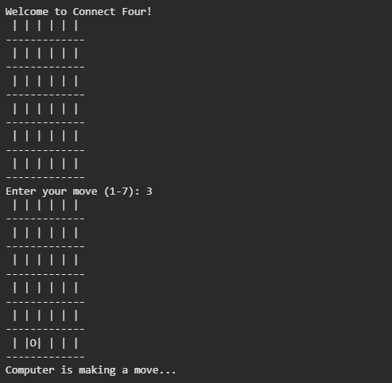

Results and Discussion:
- Perfect Play: The Min-max algorithm ensures the computer always makes the best possible move, guaranteeing a win or a draw at worst.
- Efficiency Considerations: Connect Four, with its larger game tree, might require optimizations such as alpha-beta pruning to reduce the computation time and evaluate fewer branches.

Conclusion:
In this lab, we implemented the Min-max algorithm to make optimal decisions for the computer player in Connect Four. The computer plays perfectly, either winning or drawing against the human player. Further work can focus on optimizing performance with techniques like Alpha-Beta Pruning for faster decision-making.

Future Work:
- Implement Alpha-Beta Pruning to improve the Min-max algorithm's efficiency.
- Extend the implementation to other strategic games with more complex game trees, such as Chess or Checkers.
- Create a graphical user interface (GUI) for a more interactive gaming experience.

